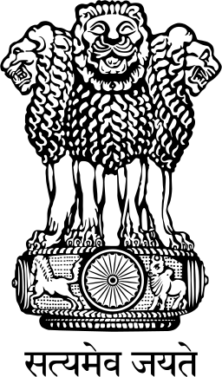

**GOVERNMENT OF INDIA**

**OFFICE OF THE DIRECTOR GENERAL OF CIVIL AVIATION OPP. SAFDARJUNG AIRPORT, NEW DELHI -110 003**

****

**PUBLIC NOTICE**

**MEDICAL DIRECTORATE**

Telephone No. 01124610629

File Reference No. AV/22025/25A/DMS/Med Date - 30 Sep 19

**SUBJECT:** **REQUIREMENT OF PHOTOGRAPH**

**AND A SELF ATTESTED PHOTOCOPY OF IDENTITY PROOF DURING MEDICAL EXAMINATION**

1. During Civil Aircrew Medical Examination, CA Form 34 / 34A / 35 are filled up by DGCA empanelled Class 1 & 2 Medical Examiner, DGCA empanelled IAF / AF Centres & DGCA empanelled Civil Class 1 Initial Centres and are approved / assessed by the Medical Assessors at DGCA.

2. Henceforth, during the conduct of all aircrew medical examinations, the pilot should attach a current passport sized photograph with his / her name & date of photograph mentioned below that photograph, alongwith a self-attested photocopy of an identity proof i.e Passport / Aadhaar Card. e) Election Photo Identity Card (EPIC) issued by the Election Commission of India (Voter ID) / License with CA Form 34 / 34A.The original of the same must be carried by the pilot for perusal by the medical examiner/center.

Director General of Civil Aviation